QUESTION 1 – PROCESSES AND PROCESS STATES

1. Introduction
A process is a program that is currently under execution. The operating system manages processes by allocating CPU time, memory and other resources.
In an online examination server, thousands of students may log in and attend examinations simultaneously. Therefore, efficient process management is required to handle multiple student sessions without affecting system performance.

2. Problem Description
Consider an online examination server where 2,000 students log in simultaneously. Each student requires a separate examination session to answer questions and submit responses.
If a separate process is created for every student, the system may experience high memory consumption and context-switching overhead.
The objective is to implement process creation using the fork() system call and observe the behaviour of multiple student sessions.

3. Process State Diagram
A process moves through different states during its execution.
Main process states:
- New – A process is created.
- Ready – The process is waiting for CPU allocation.
- Running – The process is currently executing.
- Waiting – The process is waiting for an I/O operation or event.
- Terminated – The process has completed execution.

Process State Transition:

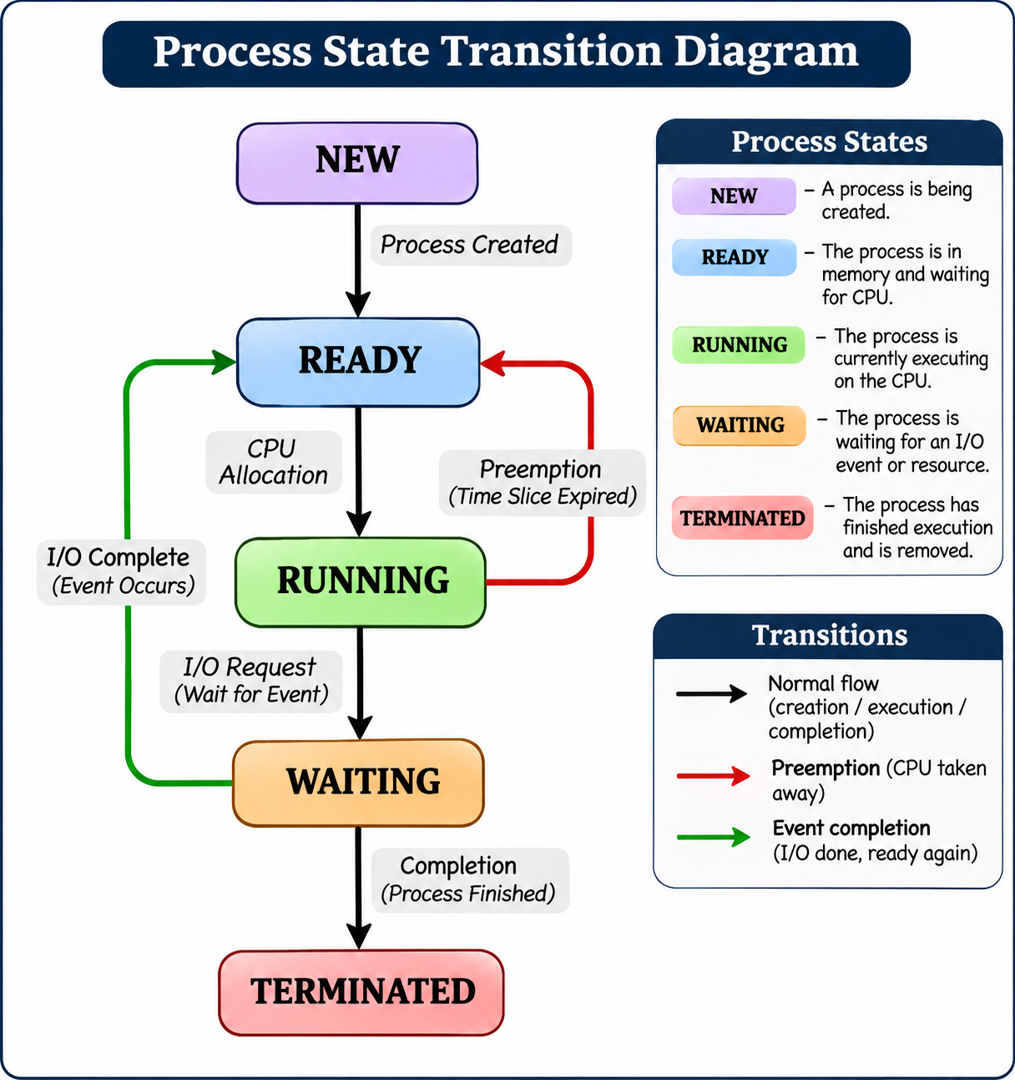

4. Process Control Block (PCB)
The Process Control Block is a data structure maintained by the operating system to store information about each process.
The PCB contains:
- Process ID (PID).
- Parent Process ID (PPID).
- Process State.
- Program Counter.
- CPU Registers.
- Memory Management Information.
- Scheduling Information.
- I/O Status Information.
The PCB helps the operating system manage and switch between different processes.

5. Implementation and Execution
The program was implemented in C using the fork() system call.
The parent process creates multiple child processes representing student examination sessions. Each child process executes independently and completes its assigned session.
Commands used:
mkdir -p ~/OS_Assignment_2/Q1
cd ~/OS_Assignment_2/Q1
nano q1.c
gcc q1.c -o q1
./q1
The ps command was also used to examine the process hierarchy.
ps -o pid,ppid,stat,cmd --forest -C q1
The /proc filesystem can also be used to examine process information.

6. Output Analysis
The program successfully started the online examination server and created three sample student sessions.
The output showed:
- Online Examination Server Started.
- Parent process created successfully.
- Student Sessions 1, 2 and 3 started.
- Some sessions entered the waiting state for I/O.
- All student sessions completed.
- Online Examination Server Stopped.
The process hierarchy was also checked using the ps command. The output displayed the parent process and its child processes.
Screenshot Placement:
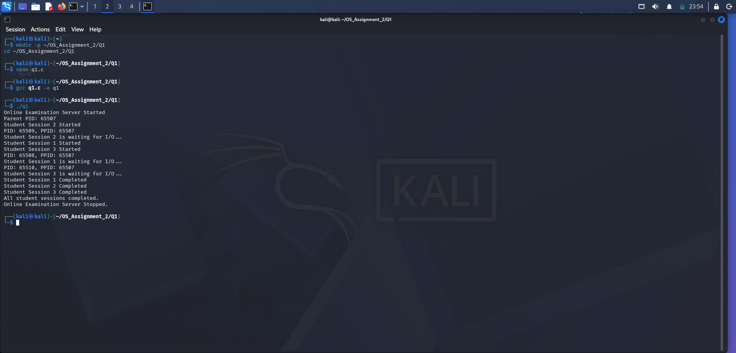
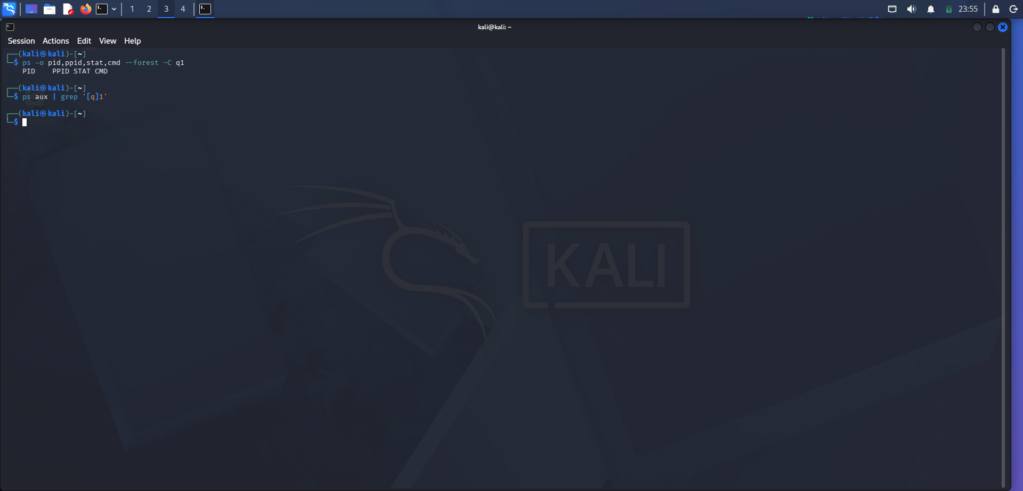

7. Design Decision and Evaluation
Creating a separate process for every student provides better isolation because each process has its own address space. However, creating 2,000 processes requires additional memory and increases context-switching overhead.
A better approach for the examination server is to use one thread per student session or a fixed-size worker thread pool.
A worker pool can reuse existing threads instead of continuously creating new ones. This reduces resource consumption and improves scalability.

8. Alternative Concept and Complexity Analysis
If every student session is managed using a separate process, the operating system must maintain a separate PCB and process address space.
For N student sessions, the management overhead increases with the number of processes.
A thread-based approach shares the address space of the main application and generally requires fewer resources. However, synchronization is required to protect shared examination data.
A fixed-size worker pool provides a balance between performance, memory usage and resource management.

9. Conclusion
The experiment successfully demonstrated process creation and management using the fork() system call. The parent-child process relationship was verified using the ps command.
For a large online examination system, a fixed-size worker pool is a suitable design because it reduces process creation overhead and improves resource utilization.

